THESIS

WESTERN SPRUCE BUDWORM OUTBREAK ASSOCIATED WITH WET PERIODS IN THE COLORADO FRONT RANGE: A MULTICENTURY RECONSTRUCTION

Submitted by

Olivia Santiago

Department of Forest and Rangeland Stewardship

In partial fulfillment of the requirements

For the Degree of Master of Science

Colorado State University

Fort Collins, CO

Summer 2022

Master’s Committee:

Advisor: Sarah Hart

Miranda Redmond

Sara Bombaci

Copyright by Olivia Santiago 2022

All Rights Reserved

ABSTRACT

WESTERN SPRUCE BUDWORM OUTBREAK ASSOCIATED WITH WET PERIODS IN THE COLORADO FRONT RANGE: A MULTICENTURY RECONSTRUCTION

Western spruce budworms (WSB) are one of the most important native defoliators of coniferous forests in North America, causing widespread reductions in tree growth and elevated levels of tree mortality during outbreak. Like other eruptive insects, outbreaks of WSBs are thought to be influenced by a broad regional driver such as climate. Documentation of WSB outbreak is limited to the mid-20th century, constraining our understanding of how climate may influence outbreak. Previous research has linked periods of outbreak with both anomalously wet and dry periods in the Southwest and Pacific Northwest, respectively. To assess this relationship in the Colorado Front Range, I used tree ring methods to reconstruct periods of WSB outbreak over 437 years (1564-2001) at 15 sites. I detected 102 outbreak periods lasting on average 9.7 years (±1.0) with 27.7 years (±7.2) between outbreak periods. These outbreaks were regionally synchronous and were most common during wet periods that followed periods of average or low moisture. Considering the potential impacts of WSB defoliation on the provisioning of key ecosystem services, including carbon sequestration, provisioning of timber, and wildlife habitat, the findings provide valuable information for forest scientists and managers responsible for promoting forest health and resilience.

TABLE OF CONTENTS

ABSTRACT .................................................................................................................................. ii Chapter 1 – Climate patterns associated with western spruce budworm outbreak in the Colorado Front Range …………………........................................................................................................ 1

Introduction …………….................................................................................................... 1

Research Questions and Hypotheses…………………………………………….. 5

Materials and Methods ...………….................................................................................... 8

Study Area………………………………………………………………………...8

Dendrochronological methods…………………………………………………...10

Detecting defoliation in individual trees…………………………………………12

Detecting periods of outbreak……………………………………………………13

Data Analysis ................................................................................................................... 14

Outbreak characteristics………………………………………………………….14

Regional level synchrony………………………………………………………...14

European colonization…………………………………………………………...15

Associations between climate and outbreak of WSB……………………………16

Results .............................................................................................................................. 16

Outbreak characteristics………………………………………………………….16

Regional synchrony of outbreak…………………………………………………20

Influence of European colonization……………………………………………...21

Climatic patterns associated with outbreak………………………………………21

Discussion ….................…............................................................................................... 24

Outbreak histories………………………………………………………………..25

Inter-site outbreak synchrony and driving factors……………………………….25

Precolonial and modern outbreak dynamics……………………………………..25

Outbreaks and climatic variability……………………………………………….26

Uncertainties and limitations…………………………………………………….27

Conclusion …................................................................................................................... 28

Acknowledgements …...................................................................................................... 29

Literature Cited …............................................................................................................ 29

Supplements ..................................................................................................................... 33

CHAPTER 1 – Climate Patterns Associated with Outbreaks of Western Spruce Budworm in the Colorado Front Range

1. Introduction

Global change, including changes in climate and land-use, is driving dramatic change in ecosystems around the world (Bennet & Radford 2008). In forested ecosystems of western North America, global change has been linked to changes in plant-insect interactions (Bale et al. 2002). Such changes may lead to important changes in ecosystem structure, composition, and function especially when insect herbivores increase consumption in response to elevated temperatures, CO2 concentrations, drought stress, and nutrient conditions (Hamann et al. 2021). Predicting the effects of global change on the structure, composition, and function of forest ecosystems requires a better understanding of the effects of global change on interactions between plants and insects.

The western spruce budworm (WSB, *Choristoneura freemani*) is a conifer-feeding budworm native to North America, where it feeds predominantly on Douglas-fir (*Pseudotsuga menziesii*)*,* true firs (*Abies* spp.), spruce (*Picea* spp.), and western larch (*Larix occidentalis*) (Pederson et al. 2011). The WSB completes its life cycle in a single year. The eggs hatch in the late summer and first instars migrate to overwintering sites under bark scales or in and among lichens on the trunk or limbs, where they build silken cocoons to overwinter in (Fellin & Dewey, 1982). The developing budworms then emerge in spring in their second instar and feed upon buds and old needles from April to June until new needles emerge. The larvae web these new needles together to feed in a protective shelter through the sixth instar. They then pupate in these shelters and emerge as adults in August, when the females lay up to 130-150 eggs on the underside of a needle and die (Fellin & Dewey 1982, Pederson et al. 2011).

Defoliation by the WSB typically causes reductions in growth (Pederson et al. 2011). However heavy defoliation may lead to tree death, particularly in smaller, suppressed trees and saplings (Pederson et al. 2011). Additional effects of WSB defoliation include growth loss from top-kill, deformation, reduced seed production, and increased risk of mortality from subsequent bark beetle attacks (Pederson et al. 2011, Cole et al. 2022), cementing it on the landscape as one of its most important defoliating insects.

Typically, WSBs exist at low population levels and defoliation is minimal, but periodically populations increase dramatically leading to widespread defoliation (Pederson et al. 2011). Typically, predation keeps WSB at endemic levels (Flower et al. 2014), although the population can grow to exceed this top-down control during outbreak. However, what allows populations to escape that top-down control and the exact mechanisms that drive WSB outbreak are not yet well understood, in part because the short record of historic outbreak requires research to focus on documented (post-1920) outbreak periods which excludes many outbreak events and limits the ability to assess climatic drivers over time. Outbreaks of WSB are most likely to occur in severely disturbed multistoried stands with high host densities of varied stem sizes (Hadley & Veblen 1993). Given susceptible stand conditions, outbreaks may occur synchronously across regions and even continents (Ellis & Flower 2017, Flower 2016, Flower et al. 2014, Swetnam & Lynch 1989, 1995), suggestive of a broad-scale driver such as climate. Like other insects, WSB population dynamics are sensitive to variation in temperature. For example, the WSB experiences increased overwintering survival during warmer winters (Régnière & Nealis 2019). The survival of emerging instars in the spring depends on the availability of quality food produced by host trees, which is influenced by moisture availability. During periods of moisture stress, host trees may respond by sending the nutrients of stressed tissues into areas of new growth that are readily available for young herbivores, increasing their survival and removing them from the pressures of predation or parasitism (Plant Stress Hypothesis, White 1984). However, herbivores cannot access nutrients trapped in wilted tissues during periods of extended drought, and therefore do not benefit from increased reproductive success. During periods of high moisture availability, a host tree may allocate more energy into increasing the growth of new tissues, leading to larger and more abundant leaves that are then available to herbivores (Plant Vigor Hypothesis, Price 1991). Alternatively, punctuated drought provides the opportunity for plants to recover some of the water content in their tissues which makes the nutritious sap and its benefits accessible to herbivores again. Therefore, herbivorous insects have the greatest reproductive success during wet periods that follow drought (Pulsed-Stress Hypothesis, Huberty & Denno 2004).

However, understanding the exact mechanism by which climate influences outbreak of WSB has been challenging as these events happen infrequently on the landscape. The uncertainty surrounding WSB outbreak persists because of a lack of long-term, broad-scale, high quality data. For instance, the United States Forest Service records extend into the early 1900s. This lack of data obscures the influence of climate on WSB outbreaks, and how that influence might be changing compared to historic norms due to the rapidly changing modern climate. Additionally, evidence suggests there may be regional differences in how WSB outbreak responds to climate (Flower 2016, Xu et al. 2019), however the mechanism underpinning this variation is unclear.

Dendrochronology is often employed to elucidate the main drivers of outbreaks because they can be used to build multi-century records of outbreak (Swetnam & Lynch 1989). Dendrochronological studies have been employed throughout North America to understand the climatic patterns associated with outbreak of the WSB, although none have been conducted in the Colorado Front Range since the late 1980s (Swetnam & Lynch 1989). These studies suggest that outbreaks of the WSB are associated with anomalous variation in precipitation, although the direction of the relationship appears to vary based on geographic location. In the Pacific Northwest, dendrochronological reconstructions of WSB outbreaks suggest that outbreaks tended to occur at the end of droughts (Ellis & Flower 2017, Flower et al. 2014). The reconstructions of the Rocky Mountains showed a similar pattern, revealing a regionally synchronous pattern of outbreaks concurrent with a period of increased moisture after a drought (Ryerson et al. 2003, Flower 2016). However, an aerial detection survey from 1997-2015 found that multiple years of drought occurred prior to and during outbreak initiation in the Northwest but that the Southwest was associated only with weak drought or neutral conditions (Xu et al. 2019).

Dendrochronological methods have also been employed to understand the synchronicity of outbreaks of the WSB in North America. The reconstructions of British Columbia showed strong synchrony for some, but not all outbreak events (Axelson et al. 2015), a consistent number of outbreaks since the 1800s (Alfaro et al. 2014), and evidence that hosts may be increasingly susceptible to successive defoliation events since the 2000s (MacLauchlan et al. 2018). A regional study that looked at WSB outbreaks over the entirety of western North America found that this regional synchrony extends to the whole of the continent and appears to be a natural part of the population dynamics of WSB (Flower 2016), although synchronous outbreaks have occurred more frequently during the 20th century, likely due to climate change and changing land use regimes (Ellis & Flower 2017). In total, the studies suggest drought and (or) moisture availability play a key role in influencing the initiation of outbreak and that outbreaks may be occurring more frequently in modern times.

To better understand the drivers of WSB outbreaks, we used tree-ring methods to produce a 437-year record of WSB outbreak across 15 sites in the Colorado Front Range. We used this record to characterize regional synchrony, investigate the potential association between WSB outbreaks and drought, and determine if European colonization, and associated changes in forest structure and composition, led to changes in WSB outbreak dynamics. The information collected is critical to better understand climate’s influence on plant-insect interactions that are vital to the health of the ecosystem and economy of Colorado and to complete the understanding of the drivers of WSB outbreak in western North America.

*Research Questions and Hypotheses*

Our research investigates the role of climate in broadly synchronous outbreak of the WSB in the Colorado Front Range but acknowledges that land-use changes may also be an important driving factor of outbreak. Therefore, we ask three questions to understand the characteristics of these outbreaks as well as how they might be driven by variations in climate or land use changes. Specifically, we ask (1) Over the past 437 years, **have WSB outbreaks initiated and ceased synchronously across the Front Range?** (2) **Have changes to forest structure and composition caused by European colonizers changed outbreak duration, quiescent period, or severity?** (3) Is drought associated with the initiation or cessation of WSB outbreaks?

**Hypothesis 1: Outbreaks initiated and ceased synchronously in the Front Range.** First, we expect to see that like other studies in North America, the outbreaks of the Front Range are synchronous across the whole region as has been reported in other studies in North America. Although the driving factors of outbreak are not yet fully understood, climate has been strongly suggested because it affects broad landscapes at once. The specific mechanism by which climate may synchronize outbreak is less clear. Potentially, it creates forest conditions that are ideal for sustaining outbreak (Hypothesis 3). Alternatively, it increases budworm survivorship by decreasing the time between budworm emergence from hibernation and the beginning of host bud flush in the spring. This strengthened phenological match between plant-and-herbivore benefits the herbivore by reducing starvation during spring foraging.

**Hypothesis 2: Outbreak characteristics (duration, quiescent period, or severity) have changed since the period of European colonization.** The study area is the historic home of the Ute and Arapaho nations who acted as the main stewards of the land until they were displaced by European colonizers in the late 1850s during the gold rush of Colorado (statehood 1876). Colonial fire suppression in the west led to increased stand density (Merrill et al. 2003) resulting in forests with higher densities of Douglas fir (Swetnam & Lynch 1993). This may result in differing outbreak dynamics before the period of colonization (pre-1870) and after (post-1870). Higher density forest structure favors shade-tolerant species, such as WSB host Douglas fir, increasing its absolute density on the landscape, as well as its relative density. Outbreaks of the WSB are most common in multistoried stands with high host densities, therefore, we expect to see that this is reflected by significant changes in outbreak dynamics before and after the period of colonization in Colorado.

Our research mainly focuses on climate as a potential driver of WSB outbreak because it may explain why these outbreaks are synchronous across broad landscapes, as well as why they seem to occur in longer cycles. We specifically ask how the climate influences host condition to best promote budworm survival, leading to outbreak. Because this interaction is complex, we present three alternative hypotheses to explain the mechanism by which climate, specifically drought, may lead to host conditions that greatly increase budworm survival and fecundity during the critical period in the early spring when early instars emerge from hibernation and host trees produce bud flush. Although temperature likely has important effects as well, tree rings in the southwest are most responsive to variations in precipitation as it is a water-limited system, therefore, our questions focus on drought.

**Hypothesis 3a: Outbreak is initiated during periods of drought.** During the foraging period in early spring, young instars of the WSB experience increased survivorship with access to the concentrated nutrients in bud flush as a result of host response to drought. Water-stressed plants concentrate nutrients in the sap and send it to areas of storage or, more importantly, new growth, which becomes readily accessible to herbivorous insects, increasing the survivorship and fecundity of WSB during drought (Plant Stress Hypothesis, White 1984).

**Hypothesis 3b: Outbreak is initiated during periods of above average moisture.** During the foraging period in the early spring, young instars of the WSB experience decreased competition and increased survivorship with access to abundant sources of new growth as a result of hosts response to wet conditions. Plants grow vigorously with access to abundant moisture and provide more food than average for herbivorous insects, increasing the reproductive success of WSB during periods of above average moisture (Plant Vigor Hypothesis, Price 1991).

**Hypothesis 3c: Outbreak is initiated by periods of average or above average moisture following drought.** Herbivores cannot access nutrients trapped in wilted tissues during periods of extended drought, and therefore do not benefit from increased reproductive success. Punctuated drought provides the opportunity for plants to recover some of their foliar water content which makes the nutritious sap and its benefits accessible to herbivores again. Therefore, herbivorous insects have the greatest reproductive success during wet periods that follow drought (Pulsed-Stress Hypothesis, Huberty & Denno 2004).

1. Materials and Methods

*Study Area*

The study area is the montane zone (1500-3000 m) of the Colorado Front Range, which extends from the Wyoming boundary in the north to Mt. Evans in the south or between 38.30° and 40.36° of latitude (Fig. 1). This region typically experiences warm summers (mean July maximum temperature 24.1 °C) and cold winters (mean January minimum temperature -8.3 °C). Precipitation is distributed bimodally throughout the year, with peaks in April-May and July-August (mean annual precipitation 625 mm) (PRISM Climate Group, 2020; Romme et al., 2009). About 55% of the Colorado Front Range is forested (Homer et al., 2020). Montane forests in the Colorado Front Range are dominated by ponderosa pine (*Pinus ponderosa*) and Douglas fir (*Pseudotsuga menziesii*)*,* with additional presence of blue spruce (*Picea pungens*) and aspen (*Populus tremuloides*), lodgepole pine (*Pinus contorta*), and limber pine (*Pinus flexilis*) (Veblen & Donnegan 2005). These forests support wildlife, timber resources, and recreation, making them ecologically, economically, and socially important.

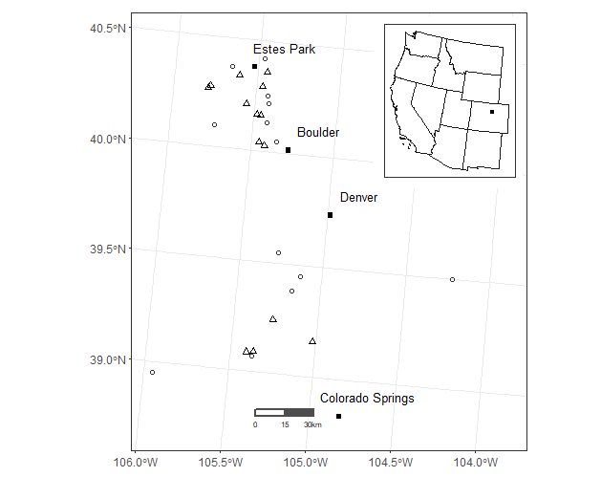

*Figure 1. Map of the study area.* The host sites (triangles) sampled by Veblen et al. (unpublished) in the late 1990s and nonhost sites (circles)downloaded from the International Tree Ring Database. The inset map shows where the study area (point) is relative to the rest of the western United States.

Across the study area we analyzed unpublished tree-ring records of western spruce budworm defoliation from 15 sites collected by Veblen et al. (unpublished) in the 1990s (Fig. 1). These sites had no recent fire activity or logging at the time of sampling to control for factors that would mask growth suppression periods from WSB outbreak. We used two common and broadly distributed tree species to create host chronologies (Douglas fir, *Pseudotsuga menziesii*) and nonhost chronologies (Ponderosa pine, *Pinus ponderosa*) to reconstruct WSB outbreak and climate, respectively. These two species have been shown to respond similarly to climate (Ellis and Flower 2017) but differently during periods of outbreak, in which Douglas fir shows suppressed radial growth. We used existing Douglas fir (Veblen et al., unpublished) and ponderosa chronologies (International Tree Ring Database, ITRDB). The 15 host sites collected by Veblen had a range of 16 to 46 trees per site, with 381 trees in total. The 17 nonhost sites collected by the ITRDB had a range of 12 to 66 trees per site, with 577 trees in total.

*Dendrochronological methods*

This method works by using radial tree-ring widths to infer the environmental conditions in which a tree was growing, which is understood to reflect tree age, climate, and disturbances (Swetnam et al. 1985). We achieve this by creating a host and nonhost chronology for each site. A chronology is a dated record of normalized growth for each year the tree lived and is also a site average of growth based on individual trees, in which the effects of tree age and individual site characteristics are removed by detrending the series (Swetnam et al. 1985). The growth recorded by the nonhost chronology is assumed to be mainly influenced by climate, therefore, when its indices of growth are removed from the host chronology, we assume that the remaining signal is influenced by defoliation (Swetnam et al. 1989). We identify periods of significant growth suppression as signals of defoliation in an individual series, and if many series show these signals, we identify a site-level outbreak in the chronology.

The raw tree ring data includes growth resulting from every event in the life of a tree, which masks growth that can be attributed to climate or defoliation only. Therefore, we removed noise ascribed to age or individual site variation by fitting data to lines or curves in a process called detrending. Each tree in the 15 host sites (Veblen, unpublished, 381 trees) and 17 nonhost sites (ITRDB, 577 trees) creates a record of growth called a series, and each series is detrended individually. To remove the age-growth trend, we first detrended all ring width series using a negative exponential curve followed by a 100-year cubic smoothing spline with a 50% frequency response to remove multidecadal trends due to climate. This method produced the least noise in the data and retained the most information in series that are assumed to have records that mainly reflect the influence of climate or defoliation (Maclauchlan et al. 2018). Then, to remove temporal autocorrelation, we prewhitened the series using an autoregressive linear model, where the level of complexity was selected based on minimizing Akaike’s Information Criterion (AIC). All detrending was performed in R (R Core Team 2022) using the package dplR (Bunn 2008).

The detrended series must be combined into a single record to create a chronology that represents a history of climate or defoliation on a site-level. We used the dplR function *chron()* to create standardized and prewhitened chronologies that represent normalized growth and growth free from temporal autocorrelation, respectively. We used robust means to average standardized and residual chronologies together to create a chronology that is resistant to the effect of outliers and small departures for each host and nonhost site as it combines a wide range of probability distributions. This resultant average chronology is now assumed to represent a site-level history of climate (17 nonhost sites, *P. ponderosa*) or defoliation (15 host sites, *P. menziesii*).

Radial tree growth reflects all environmental conditions a tree experienced in its life; however, our questions concern only climate and defoliation. Consequently, to understand the effects of climate on defoliation, it is critical to create a non-biased history of climate for each host site (15). Therefore, we created an average climate chronology of the top three correlated nonhost (*P. ponderosa*) sites for each host site (*P. menziesii*) using principal component analysis (PCA). We correlated host and nonhost chronologies from the host sites using a simple Pearson’s correlation. For each host site (15), we chose the top three nonhost sites based on the correlation that were within 30 km. Then, we used a principal component analysis (PCA) to create site-specific composite climate chronologies from the top three nonhost chronologies. PCA expresses the most essential information of multivariate dataset as a set of new linear variables called “principal components.” We chose the first principal component as the acting climate chronology because it explains most (average 79.3%) of the variance between the three nonhost chronologies that were used in the PCA. This ensured that site-specific climate variation was captured and removed in our detection of site-level defoliation and outbreak.

*Detecting defoliation in individual trees*

To understand how individual trees experienced herbivory by the WSB over time, we created histories of defoliation for each series. We detected tree-level defoliation for each tree in a site using the criteria laid out in Swetnam & Lynch 1989. We used site-specific composite climate chronologies to remove environmental effects. These criteria were applied using the R package dfoliatR (Guiterman et al. 2020). Specifically, we defined periods of defoliation as lasting at least 8 years in which the maximum amount of growth reduction was -1.28 normalized growth suppression index (NGSI) units. Additionally, we bridged events that were only separated by a single year to connect what would have been two separate outbreak events (Ellis & Flower 2017). In this way, we attempted to control events other than defoliation that could have reduced growth significantly over the centennial record by focusing on patterns attributed specifically to WSB.

*Detecting periods of outbreak*

With an understanding of how individual trees on a site experienced defoliation on a site over time, we can expand our view to how entire sites experienced outbreak over time by looking for periods where many trees (≥ 40%) experienced significant defoliation. We detected periods of site-level outbreak using the R package dfoliatR (Guiterman et al. 2020) using the criteria defined in Ellis & Flower 2017. Specifically, we identified outbreak where 1) values of the corrected indices are less than the expected growth of 1.0 for three or more years and 2) the lowest growth value during this period was greater than 1.28 standard deviation below the mean of the series (Swetnam & Lynch 1989). We required a sample depth of at least three series for each year in the record, and where there were only three series, we required that at least two of the three series recorded defoliation. This ensures that the beginning and end of the record are not only represented by one series which could bias the results based on individual growth and site effects that cannot be removed by detrending alone. Similarly, we filtered periods of outbreak less than 4 years to ensure that other defoliating insects were not included in the analyses. Furthermore, to ensure outbreaks identified truly occurred on a site-level, we only included outbreaks that affected at least 40% (Ellis & Flower 2017) of trees on a site.

1. Data Analysis

*Outbreak characteristics*

We summarized the results of each host chronology into a table (Table 1) of the length of each site’s record, duration of outbreak, quiescent period between outbreaks, and percentage of the record that had outbreak conditions. The duration of outbreak is equal to the number of years between the beginning and ending years of an identified outbreak. Similarly, the quiescence period is the number of years between the last year of one outbreak and the first year of another outbreak, or the amount of time between outbreaks. The percentage of the record with outbreak conditions is equal to the sum of each outbreak duration over the total length of each site’s record multiplied by 100.

To visualize general patterns of outbreak in the 437-year reconstruction we created a plot (Fig. 2) of annual climate, sample depth, and severity. Annual climate was represented with Palmer’s Drought Severity Index (Cook et al. 2008) for the study area. The sample depth was calculated as the number of trees included in a record per year, where years with less than 3 trees were excluded. The severity of outbreaks was calculated using the percentage of trees in a year that were significantly defoliated during an outbreak event.

*Regional level synchrony*

To confirm that outbreaks of the WSB occurred synchronously across the study area, we used two methods. First, we used Pearson’s correlation (*r*) to quantify the similarity of outbreak between sites using percent defoliation of each site by year. We then assessed the temporal synchrony of outbreaks across sites over a common period of 1800-1990 using bivariate event analysis, a form of Ripley's K that has been modified for one direction (here time) (Gavin et al., 2006). Then, we used bivariate event analysis to understand whether outbreaks were likely to cluster together in time using the years of initiation and cessation of outbreak in all sites using the first (or last) year of outbreak for all outbreaks. We understand that the patterns seen here may be clouded by the influence of topography on the initiation and cessation of outbreak, as sites on different slopes or aspects may have experienced different microclimates that amplified or dulled the effect of climate anomalies such as drought.

*European colonization*

To understand if changes in forest structure or composition caused by European colonization of western North America influenced the duration, quiescent period, or severity of WSB outbreak, we used a Welch’s t-test to compare outbreak characteristics prior to and after European colonization. Following Ellis & Flower (2017), we assumed that colonization and thus changes to forest conditions began in 1870. Future iterations of this analysis will use a generalized linear mixed model to account for the differences between the two groups despite the non-normal distribution of the data and small sample sizes.

*Associations between climate and outbreaks of WSB*

To understand the relationship between annual climate variation and outbreak, we first downloaded time series of the Palmer Drought Severity Index (PDSI) from the North American Drought Atlas (Cook et al. 2008). For each site, we downloaded the time series from the nearest PDSI grid cell. We then used superposed epoch analysis (SEA; Lough and Fritts 1987) to understand if PDSI was significantly associated with years of outbreak initiation and (or) cessation. SEA compares the mean climate conditions (PDSI) during the years preceding and following each key event year (year of outbreak initiation or cessation) with a null distribution generated using a bootstrap resampling approach. We first used SEA to determine if PDSI significantly deviated from normal using the pooled records of years of outbreak initiation and cessation at any site across the study area. Additionally, we performed SEA for each site individually. We then summarized the results of the site-specific SEAs to count the number of sites that experienced a significant departure from the mean PDSI as either wet years (positive PDSI) or dry years (negative PDSI). For both analyses, we used an 11-year window, which has been widely used in previous studies (Ellis & Flower 2017, Flower 2016, Flower et al. 2014).

1. Results

*Outbreak characteristics*

Individually, the 15 sites each experienced 3 to 11 outbreak events. Across the 15 sites, we detected 102 outbreak events over 437 years (1564-2001) that affected at least 40% of the trees sampled at a site. The duration of detected outbreaks at each site ranged from 8 to 11 years and averaged 9.3 (±1.0) years. The quiescent period at each site ranged from 20 to 48 years and averaged 27.7 (±7.2) years. The percentage of years where outbreaks were identified out of the entire length of the individual site records was 9 to 39%, averaging 26% (±7.6) across all sites.

Table 1. Summary of outbreak characteristics for each site.

|  |  |  |  |  |  |
| --- | --- | --- | --- | --- | --- |
| Site | Period of record | No. of outbreaks | Mean outbreak duration (yrs) | Mean quiescent period (yrs) | % of record with outbreak conditions |
| Boulder County 18 | 1734 - 1998 | 5 | 10.4 ± 2.7 | 27.6 ± 23.8 | 24.4 |
| Boulder County 19 | 1615 - 1998 | 11 | 9.4 ± 5.3 | 19.5 ± 14.7 | 36.2 |
| Estes Park | 1615 - 1995 | 9 | 10.1 ± 1.9 | 21.8 ± 19.7 | 31.4 |
| Frankenberg Point | 1620 - 1995 | 9 | 8.1 ± 4.0 | 33.5 ± 28.7 | 22.5 |
| Lost Junction | 1571 - 1995 | 10 | 9.7 ± 3.8 | 27.2 ± 18.6 | 28.8 |
| South Hollowell | 1638 - 1995 | 3 | 9.7 ± 4.93 | 47.7 ± 68.6 | 8.8 |
| Sugarloaf Saddle | 1690 - 1995 | 7 | 8.0 ± 6.7 | 27.6 ± 29.0 | 21.0 |
| Wild Basin | 1683 - 1995 | 6 | 10.8 ± 2.9 | 25.4 ± 21.9 | 25.7 |
| West Rd 211 | 1691 - 1994 | 6 | 9.0 ± 4.1 | 31.9 ± 29.9 | 20.6 |
| Lost Jeep | 1615 - 2001 | 9 | 8.1 ± 5.3 | 28.0 ± 25.6 | 23.3 |
| Wigwam 1 | 1800 - 1983 | 5 | 8.4 ± 1.3 | 20.1 ± 11.6 | 29.6 |
| South Rd 30 | 1690 - 1987 | 8 | 10.5 ± 4.8 | 23.0 ± 13.1 | 39.3 |
| North Inlet | 1697 - 1987 | 6 | 8.7 ± 6.3 | 31.2 ± 25.9 | 20.7 |
| Three Island Lake Trail | 1564 - 1987 | 8 | 9.3 ± 4.7 | 22.9 ± 15.7 | 31.4 |

Across the study area, we found similarity in the timing of outbreak initiation and cessation. Most sites (60%) experienced an outbreak in the 1840s and 1990s, while no sites experienced an outbreak in the early and late 1600s, mid and late 1700s, the mid 1800s, and a decade around 1910 (Fig. 2). The proportion of sites experiencing an outbreak appears to increase with time, although there may be an effect of low sample size at the beginning and end of the record (Fig. 2). Furthermore, outbreaks detected in our analysis appear to align with periods of published outbreak over 1600-2000, despite differences in sampling and analytical methods (Fig. 3). Common periods of outbreak occurred during the early-to-mid-1800s, early-to-mid-1900s, and the late 1990s.

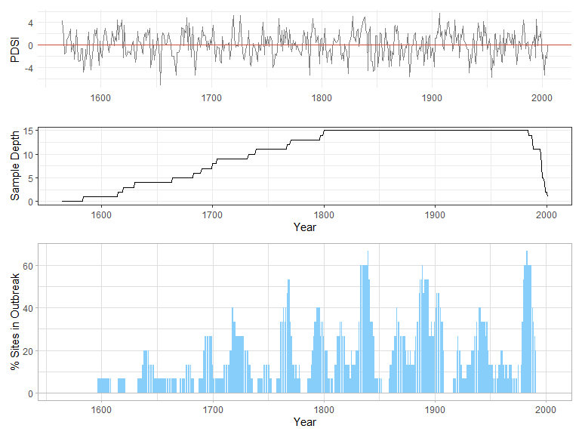

*Figure 2. Percent of sites in outbreak over time.* The top plot shows the variation in Palmer’s Drought Severity Index (PDSI) over time for the study area, where negative values indicate drought and positive values indicate above average moisture. The middle plot shows the number of individual sites that had at least three trees per year. Note that records were truncated when the sample depth was less than three trees. The bottom plot shows the percentage of the fifteen sites experiencing an outbreak over time.

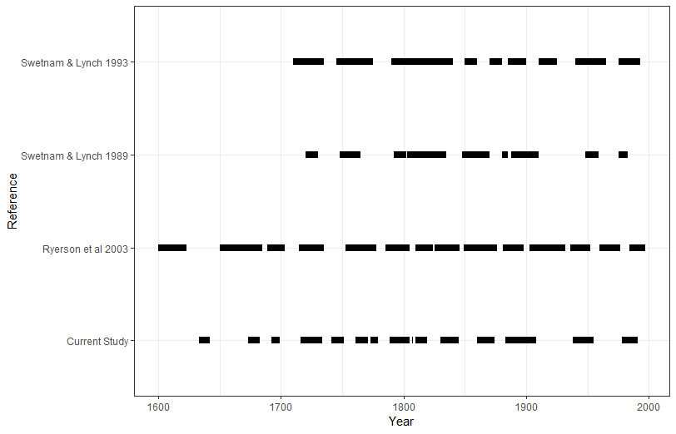

*Figure 3. A comparison of previously published periods of WSB outbreak and periods detected in the present study.*

*Regional synchrony of outbreak*

Bivariate event analysis showed that an outbreak at one site is likely to begin within less than one year of the initiation of outbreak at another site and less likely to begin when an outbreak initiated at another site 6 to 20 years later or earlier (Fig. 4). Similarly, an outbreak is likely to cease within 4 years of the cessation of another outbreak and less likely to cease when an outbreak ends at another site 7 to 20 years earlier or later.

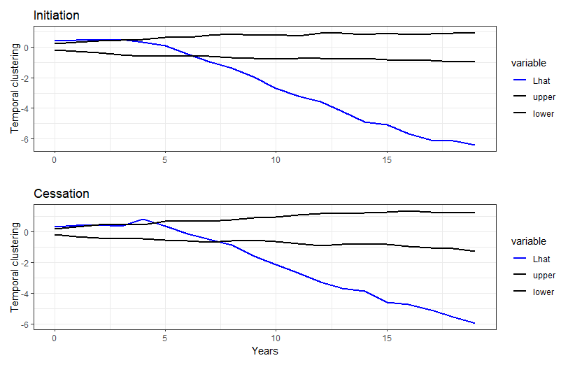*Figure 4. Temporal synchrony of outbreak initiation and cessation across all sites.* In both panels, the blue line represents the transformed version of Ripley’s *K* function. Black lines show the likelihood that initiation or cessation of outbreak at one site will correspond to the initiation or cessation of outbreak at another site and at what time lag, where positive Lhat values indicate clustering and negative Lhat values indicate dispersion. Significant values are outside the upper and lower bounds.

*Influence of European colonization on outbreak dynamics*

Across all sites, we detected 57 outbreaks during the precolonial period (1564-1870), with an average duration of 10.37 years (±4.59), a quiescent period of 39.66 years (±26.84), and average percent defoliation of 54.16% (±14.00). The modern period (1871-2001) was characterized by 43 outbreaks with an average duration of 9.16 years (±4.58), a quiescent period of years 23.87 years (±20.50), and an average percent defoliation of 51.48% (±9.94). Using a Welch’s two sample t-test, we found that mean outbreak quiescence period length differed significantly in the precolonial and modern periods (p < 0.001), but outbreak duration (p = 0.188) and percent defoliation (p = 0.271) did not significantly differ.

*Climatic patterns associated with outbreak*

When pooling years of outbreak initiation for all sites, the results of SEA show outbreaks initiated during periods of average to slightly above average moisture availability (positive PDSI; Fig. 5). However, PDSI did not significantly depart from random until five years following outbreak initiation. (Fig. 5). When examining individual sites, we also found that in contrast, outbreaks generally ceased when conditions switched from wet to average or dry (Fig. 5).

For most lagged years, less than half of the sites had a significant (p < 0.05) relationship with PDSI for either outbreak initiation or cessation at any point in the 11-year window. However, for those that did, it suggests that most sites experienced dry periods before outbreak initiation, with the outbreak beginning and subsisting in a wet period until dry conditions returned. This pattern is mirrored in the general SEA for all sites (Fig. 5), although the pattern becomes less clear when site-specific SEAs are considered (Fig. 6).

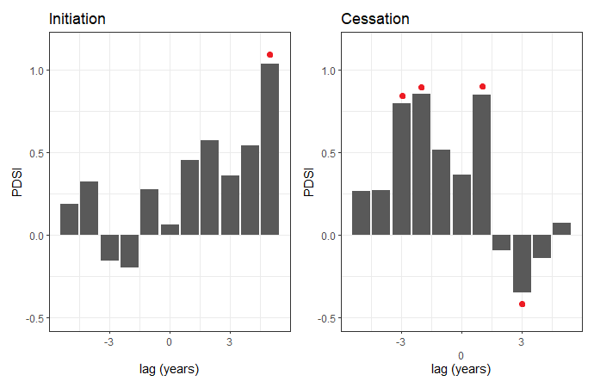

*Figure 5. Superposed epoch analysis of outbreak initiation (left) and cessation (right) for the period of 1564 – 2001.* Years of outbreak initiation and cessation are pooled across all sites. Ascending bars show a positive association between the Palmer Drought Severity Index (PDSI) and outbreak dates, descending bars show a negative association between PDSI and outbreak dates. Red dots indicate statistically significant associations.

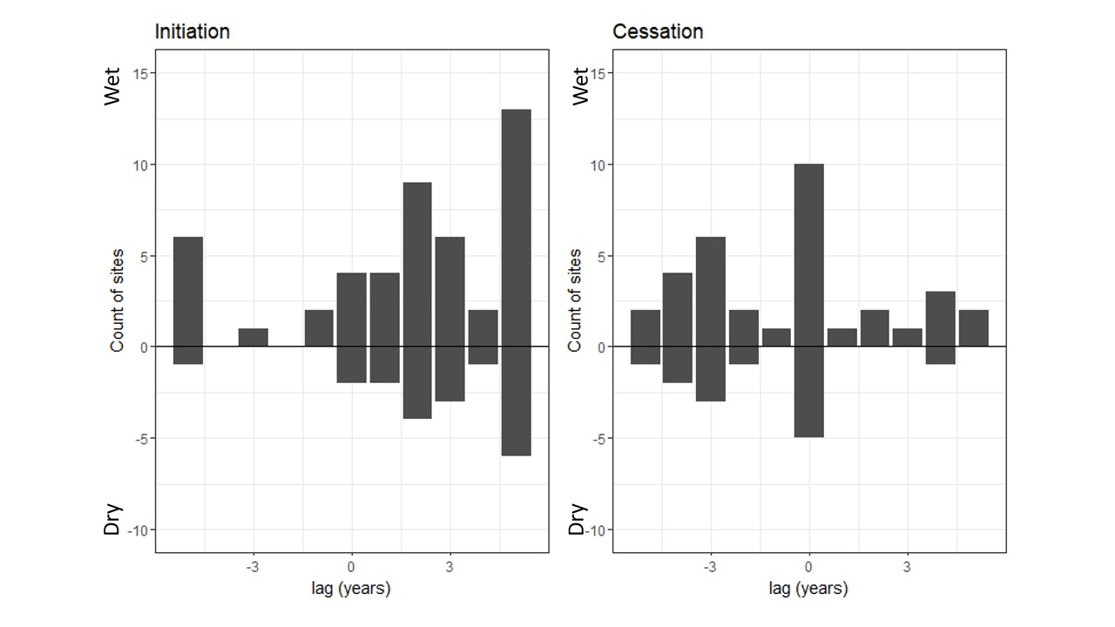

*Figure 6. The number of sites experiencing outbreak initiation or cessation in years of anomalous climate, as quantified using the Palmer Drought Severity Index.* The y-axis represents a count of sites that experienced significantly wet (positive PDSI) or dry (negative PDSI) lagged years according to site-specific SEAs.The figure shows the sum of sites experiencing a significant relationship with wet (positive values) or dry (negative values) conditions at a time lag from outbreak initiation or cessation as measured by site-specific SEAs.

1. Discussion

Using a unique dendroecological dataset of WSB outbreak, we found outbreak of the WSB occurred synchronously across the Colorado Front Range, consistent with previous research from other areas across western North America (Ellis & Flower 2017, Flower 2016, Flower et al. 2014). Furthermore, we found that these outbreaks were most common during wet periods. Namely, outbreaks were most likely to initiate during periods of average or above average moisture and to cease during periods of drought. These outbreaks have become more frequent since the period of European colonization in the late 1800s.

*Outbreak histories*

Our outbreak reconstruction revealed periods of outbreak similar to those previously published periods in Colorado and New Mexico (Swetnam & Lynch 1989, 1993, Ryerson et al. 2003). Furthermore, we found similar outbreak duration and quiescent periods to those observed in other dendroecological studies. Specifically, we found average outbreak duration and quiescent periods of 10.30 and 27.72 years, respectively. These values are similar to those documented from sites in the Okanogan Highlands (8.3 and 13.3 years; Ellis & Flower 2017), the interior Pacific Northwest (12 and 15 years Flower et al. 2014), northern New Mexico (22 and 11 years; Swetnam & Lynch 1993), and northeast Oregon (15 and 21 years; Swetnam et al. 1995). Yet, our study found the longest quiescence, suggesting that outbreaks in the Colorado Front Range may be less frequentthan at other locations. However, slight differences in sampling designs, time periods, and tree-ring processing methods across these studies preclude any definitive conclusions. Further research into the drivers of variation in outbreak duration and quiescence period is necessary.

*Inter-site outbreak synchrony and driving factors*

We found that WSB outbreak occur synchronously across the Colorado Front Range, suggestive of a broad-scale environmental driver. This supports previous work that suggested regional synchrony extends to the whole of the continent and appears to be a natural part of the population dynamics of WSB (Flower 2016). Nonetheless, not all sites experienced outbreaks during periods of regional outbreak, highlighting the role of local factors in driving outbreaks of WSB.

*Precolonial and modern outbreak dynamics*

Our results suggest that outbreaks were more common in the modern period than the precolonial period. Namely, the only significant difference between the two periods is that the quiescence has decreased during the modern period. This may be due to colonial land-use practices that suppressed fire, allowing the density of host species to increase across the landscape, creating an ideal stand structure for the WSB (Ellis & Flower 2017). This mirrors previous findings from the interior Pacific Northwest that suggested outbreaks of the WSB have become more frequent since the precolonial period (Ellis & Flower 2017). Nonetheless, we did not find an effect of European colonization on outbreak duration or severity, suggesting that although they have become more frequent, this has not changed other aspects of their dynamics.

*Outbreaks and climatic variability*

We found that outbreaks are most common in wet periods that punctuated dry or average climate conditions, although we cannot confidently say that drought leads to the initiation of outbreak. We observed a pattern in which drier conditions punctuated by periods of above average moisture sustain outbreak, and when dry conditions return, the outbreak ends. This is most similar to the punctuated-drought hypothesis proposed by Huberty & Denno 2004. Previous studies suggest that moisture availability plays a key role in driving the initiation of outbreak. Our results mirror those found in previous work that found outbreaks initiate at the end of drought (Ellis & Flower 2017, Flower 2016, Axelson et al. 2015) or during periods of above average moisture (Ryerson et al. 2003). Our study suggests that outbreaks initiated during periods of average or above average moisture following a drought in the northern Front Range. Outbreaks initiated during a year of below average moisture, and it appears as though they were able to persist because of the years of average or above average moisture that followed. Moreover, they ended with the return of dry conditions*.* However, this association was not significant for most lagged years, but this pattern was mirrored when only significant instances of PDSI across sites were observed, although it was less clear.

This unclear pattern and lack of significant findings may be due to variation in the individual site characteristics and climates as well as the lag in synchrony of outbreak initiation and cessation*.* Each site experiences its own microclimate which, when considered with other individual site variables like disturbances and forest composition, may influence when a particular site is the most vulnerable to outbreak. Furthermore, outbreaks appeared to be synchronous across the Colorado Front Range from at least 1800-1990, although initiation lagged by less than one year and cessation for 4 years. Further studies should be done to assess the influence of site-specific climatic water deficit on the timing of initiation and cessation of outbreak while taking into consideration the lagged synchrony of these events.

*Uncertainties and limitations*

Dendrochronological studies are inherently limited as a proxy for environmental and climatic events (Swetnam et al. 1985). Tree rings are not a perfect record and missing or false rings can complicate reconstructions. We attempted to control this with careful visual and statistical cross-dating (Swetnam & Lynch 1989). Additionally, there is a chance outbreaks occurred and were not captured in the radial growth of the tree due to factors outside our control such as changes in stand composition or competition or defoliation due to other insects. We aimed to control some environmental variation by normalizing our host and nonhost chronologies before removing growth effects attributed to climate from the host chronologies. For example, the tussock moth is another defoliator of Douglas fir and may reduce growth similarly to the WSB. Therefore, to control for any defoliation by the tussock moth, we removed all outbreaks less than 4 years from our record (Ellis & Flower 2017, Swetnam et al 1995). Nonetheless, tree rings remain one of the best approaches for understanding disturbances regimes characterized by disturbances that only occur once every several decades.

1. Conclusion

Outbreaks seem to initiate during periods of average conditions punctuated by periods of above average moisture. The Front Range can be expected to be the most vulnerable with continued climate warming and drying. Future research on the influence of climate on outbreak severity and spread should be investigated to prepare managers for the continued impacts of the most important defoliator in North America. Dendrochronological techniques best empower us to understand the influence of climate on outbreak because of the long records it creates that can capture several outbreaks with fine spatiotemporal data. Employing this technique across a broad, topographically diverse region such as the Colorado Front Range allowed us to answer questions about the nature of outbreak duration, extent, and spread, as well as how it is influenced by climate and topography. Our research suggests that outbreaks may become more common as climate variability increases in the western US, putting further stress on already imperiled ecosystems. Furthermore, this research builds on previous studies of WSB outbreak in western North America, which has recently been conducted in the Colorado Front Range, to complete the puzzle of the ecological factors that drive this regional ecologically and economically important disturbance.

1. Acknowledgements

We would like to acknowledge the Colorado Mountain Club for supporting this research. Additionally, this work was supported by the USDA National Institute of Food and Agriculture, McIntire-Stennis project COL00520, accession number 7002894*.*

1. Literature Cited

Alfaro, R. I., Berg, J., & Axelson, J. (2014). Periodicity of western spruce budworm in Southern British Columbia, Canada. Forest Ecology and Management, 315, 72–79. <https://doi.org/10.1016/j.foreco.2013.12.026>

Alfaro, R. I., van Akker, L., Berg, J., Van Hezewijk, B., Zhang, Q. Bin, Hebda, R., Smith, D., & Axelson, J. (2018). Change in the periodicity of a cyclical forest defoliator: An indicator of ecosystem alteration in Western Canada. Forest Ecology and Management, 430, 117–125. <https://doi.org/10.1016/j.foreco.2018.07.060>

Arango, C., Ponette-González, A., Neziri, I., & Bailey, J. (2019). Western spruce budworm effects on throughfall N, P, and C fluxes and soil nutrient status in the Pacific Northwest. Canadian Journal of Forest Research, 49(10), 1207–1218. <https://doi.org/10.1139/cjfr-2018-0523>

Axelson, J. N., Smith, D. J., Daniels, L. D., & Alfaro, R. I. (2015). Multicentury reconstruction of western spruce budworm outbreaks in central British Columbia, Canada. Forest Ecology and Management, 335, 235–248. <https://doi.org/10.1016/j.foreco.2014.10.002>

Bale, J., Masters, G. J., Hodkinson, I. D., Awmack, C., Buse, A., Coulson, J. C., Farrar, J., Good, J. E. G., Harrington, R., Hartley, S., Jones, T. H., Lindroth, R. L., Press, M. C., Symrnioudis, I., Watt, A. D., & Whittaker, J. B. (2002). Herbivory in global climate change research: direct effects of rising temperature on insect herbivores. 1–16.

Bennett, A. F., & Radford, J. Q. (2008). Emergent Properties of Land Mosaics: Implications for Land Management and Biodiversity Conservation. In Managing and Designing Landscapes for Conservation: Moving from Perspectives to Principles (pp. 199–214). Blackwell Publishing Ltd. <https://doi.org/10.1002/9780470692400.ch18>

Bunn, A. G. (2008). A dendrochronology program library in R (dplR). *Dendrochronologia*, *26*(2), 115–124. <https://doi.org/10.1016/j.dendro.2008.01.002>

Cole, H. M., Andrus, R. A., Butkiewicz, C., Rodman, K. C., Santiago, O., Tutland, N. J., Waupochick, A., & Hart, S. J. (2022). Outbreaks of Douglas-Fir Beetle Follow Western Spruce Budworm Defoliation in the Southern Rocky Mountains, USA. Forests, 13(3), 371. <https://doi.org/10.3390/f13030371>

Cook, E.R., R. Seager, R.R. Heim Jr, R.S. Vose, C. Herweijer, and C. Woodhouse, 2010: Megadroughts in North America: placing IPCC projections of hydroclimatic change in a long-term palaeoclimate context. Journal of Quaternary Science, 25, 48-61.

Ellis, T. M., & Flower, A. (2017). A multicentury dendrochronological reconstruction of western spruce budworm outbreaks in the Okanogan Highlands, northeastern Washington. Canadian Journal of Forest Research, 47(9), 1266–1277. <https://doi.org/10.1139/cjfr-2016-0399>

Fellin, D. G., & Dewey, J. F. (1982). Western Spruce Budworm.

Flower, A., Gavin, D. G., Heyerdahl, E. K., Parsons, R. A., & Cohn, G. M. (2014). Drought-triggered western spruce budworm outbreaks in the interior Pacific Northwest: A multi-century dendrochronological record. Forest Ecology and Management, 324, 16–27. <https://doi.org/10.1016/j.foreco.2014.03.042>

Flower, Aquila. (2016). Three centuries of synchronous forest defoliator outbreaks in western North America. PLoS ONE, 11(10), 1–20. <https://doi.org/10.1371/journal.pone.0164737>

Guiterman, C. H., Lynch, A. M., & Axelson, J. N. (2020). dfoliatR: An R package for detection and analysis of insect defoliation signals in tree rings. Dendrochronologia, 63. <https://doi.org/10.1016/j.dendro.2020.125750>

Hadley, K. S., & Veblen, T. T. (1993). Stand response to western spruce budworm and Douglas-fir bark beetle outbreaks, Colorado Front Range. Canadian Journal of Forest Research, 23(3), 479–491. <https://doi.org/10.1139/x93-066>

Hamann, E., Blevins, C., Franks, S. J., Jameel, M. I., & Anderson, J. T. (2021). Climate change alters plant–herbivore interactions. In New Phytologist (Vol. 229, Issue 4, pp. 1894–1910). Blackwell Publishing Ltd. <https://doi.org/10.1111/nph.17036>

Iacopetti, G., Bussotti, F., Selvi, F., Maggino, F., & Pollastrini, M. (2019). Forest ecological heterogeneity determines contrasting relationships between crown defoliation and tree diversity. Forest Ecology and Management, 448(June), 321–329. <https://doi.org/10.1016/j.foreco.2019.06.017>

Johnson, E. W., & Ross, J. (2008). Quantifying error in aerial survey data Australian Forestry (Vol. 71, Issue 3).

Larroque, J., Johns, R., Canape, J., Morin, B., & James, P. M. A. (2020). Spatial genetic structure at the leading edge of a spruce budworm outbreak: The role of dispersal in outbreak spread. Forest Ecology and Management, 461(February), 117965. <https://doi.org/10.1016/j.foreco.2020.117965>

Li, M., MacLean, D. A., Hennigar, C. R., & Ogilvie, J. (2020). Previous year outbreak conditions and spring climate predict spruce budworm population changes in the following year. Forest Ecology and Management, 458(September 2019), 117737. <https://doi.org/10.1016/j.foreco.2019.117737>

Lough, J. M., & Fritts, H. C. (1987). AN ASSESSMENT OF THE POSSIBLE EFFECTS OF VOLCANIC ERUPTIONS ON NORTH AMERICAN CLIMATE USING TREE-RING DATA, 1602 TO 1900 A.D. Climatic Change, 10, 219–239. <http://dx.doi.org/10.1007/BF00143903>

Maclauchlan, L. E., Daniels, L. D., Hodge, J. C., & Brooks, J. E. (2018). Characterization of western Spruce budworm outbreak regions in the British Columbia interior. Canadian Journal of Forest Research, 48(7), 783–802. <https://doi.org/10.1139/cjfr-2017-0278>

Merrill, K. R., Huckaby, L. S., Fornwalt, P. J., Stoker, J. M., & Romme, W. H. (2003). Using tree recruitment patterns and fire history to guide restoration of an unlogged ponderosa pine/Douglas-fir landscape in the southern Rocky Mountains after a century of fire suppression. Forestry, 76(2), 231–241.

Nealis, V., & Régnière, J. (2021). Ecology of outbreak populations of the western spruce budworm. ECOSPHERE, 12(7). <https://doi.org/10.1002/ecs2.3667>

Pederson, L., Sturdevant, N., & Blackford, D. (2011). Western Spruce Budworm. USDA Forest Service.

Price, P. W. (1991). The Plant Vigor Hypothesis and Herbivore Attack. In Oikos (Vol. 62, Issue 2). <https://www.jstor.org/stable/3545270?seq=1&cid=pdf->

R Core Team (2021). R: A language and environment for statistical computing. R Foundation for Statistical Computing, Vienna, Austria. URL https://www.R-project.org/.

Régnière, J., & Nealis, V. G. (2019). Influence of temperature on historic and future population fitness of the western spruce budworm, *Choristoneura occidentalis*. International Journal of Pest Management, 65(3), 228–243. <https://doi.org/10.1080/09670874.2018.1541113>

Reynolds, D. J., Edge, D. C., & Black, B. A. (2021). RingdateR: A Statistical and Graphical Tool for Crossdating. Dendrochronologia, 65. <https://doi.org/10.1016/j.dendro.2020.125797>

Ryerson, D. E., Swetnam, T. W., & Lynch, A. M. (2003). A tree-ring reconstruction of western spruce budworm outbreaks in the San Juan Mountains, Colorado, U.S.A. Canadian Journal of Forest Research, 33(6), 1010–1028. <https://doi.org/10.1139/x03-026>

Swetnam, T. W., Sutherland, E. K., & Thompson, M. A. (1985). *Spruce Budworms Handbook Using Dendrochronology To Measure Radial Growth of Defoliated Trees*.

Swetnam, T. W. (1989). A Tree-ring reconstruction of western spruce budworm outbreaks in the Southern Rocky Mountains Wildfire Alternatives View project Pandora moth View project. <https://www.researchgate.net/publication/228397330>

Swetnam, T. W. (1995). Historical patterns of western spruce budworm and Douglas-fir tussock moth outbreaks in the northern Blue Mountains, Oregon, since AD 1700 (Vol. 484). US Department of Agriculture, Forest Service, Pacific Northwest Research Station.

Veblen, T., and J. Donnegan. (2005). Historical Range of Variability of Forest Vegetation of the National Forests of the Colorado Front Range. USDA Forest Service, Rocky Mountain Region and the Colorado Forest Restoration Institute, Fort Collins. 151 pages.

White, T. C. R. (1984). Oecologia (Berlin) The abundance of invertebrate herbivores in relation to the availability of nitrogen in stressed food plants. Oecologia, 63, 90–105.

Xu, B., Hicke, J. A., & Abatzoglou, J. T. (2019). Drought and Moisture Availability and Recent Western Spruce Budworm Outbreaks in the Western United States. Forests, 10(4), 354. <https://doi.org/10.3390/f10040354>

1. **Supplements**

Pearson's correlation revealed that sites experienced similar outbreak patterns over time (Figure A1). However, one site, Summerland Park (SP) did not correlate closely with any of the other sites.

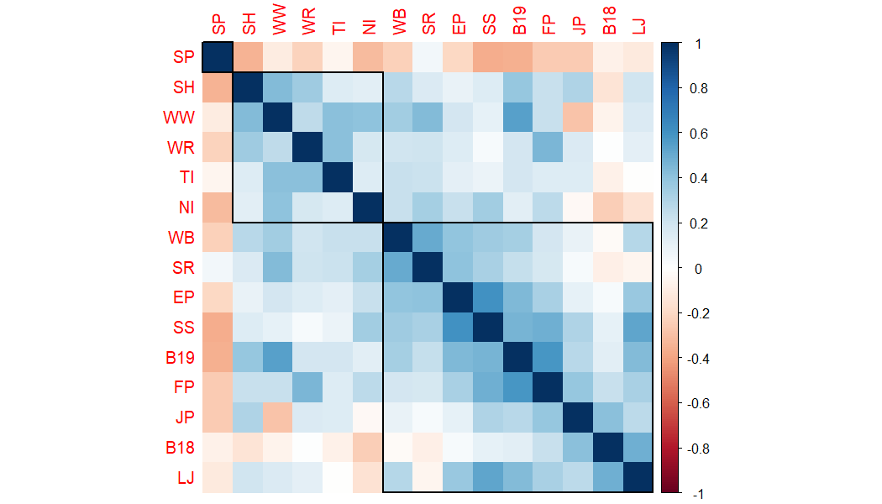

Figure S1: *Correlation between percent-defoliation per year.*

Similarly, Pearson’s correlation revealed that the site-specific composite climate chronologies were very closely correlated with each other (Figure A2). This provided evidence that these sites experience similar climates.

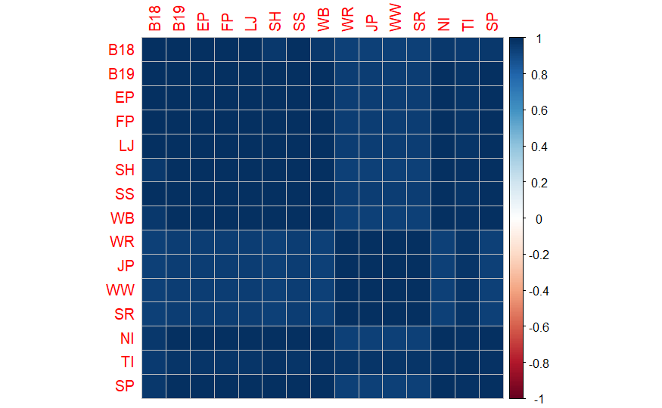

Figure S2: *Correlation between composited Ponderosa pine chronologies.*

Table S1: Site locations in the Colorado Front Range.

|  |  |  |  |
| --- | --- | --- | --- |
| Site | Latitude | Longitude | Elevation (m) |
| Boulder County 18 | 40.163209 | -105.459561 | 2421 |
| Boulder County 19 | 40.1655633 | -105.481387 | 2645 |
| Estes Park | 40.36128808 | -105.4451392 | 2643 |
| Frankenberg Point | 40.04102 | -105.45444 | 2407 |
| Lost Junction | 40.29470943 | -105.4635744 | 2619 |
| South Hollowell | 40.33630502 | -105.6075955 | 2580 |
| Summerland Park | 40.02675762 | -105.421147 | 2662 |
| Wild Basin | 40.20932 | -105.55018 | 2594 |
| West Road 211 | 39.08637737 | -105.4073351 | 2558 |
| Lost Jeep | 39.09286043 | -105.3653275 | 2582 |
| Wigwam 1 | 39.24137251 | -105.2651545 | 2017 |
| South Road 30 | 39.16006898 | -105.017466 | 2754 |
| North Inlet | 40.27536637 | -105.7763456 | 2771 |
| Three Island Lake Trail | 39.96519 | -105.510329 | 2537 |
| Summerland Park | 40.26418611 | -105.7910361 | 2623 |